MEMORANDUM

TO: Mayor Walter B. Duke, III
Vice Mayor Chickie Brandimarte
Commissioner Bobbie H. Grace
Commissioner Albert C. Jones

FROM: Robert Baldwin, City Manager

BY: Dominic F. Orlando, P.E. Director of Public Services

Date: February 26, 2014

RE: Change Order #1 to the Lime Softening Plant Rehabilitation - Lead Paint Abatement Bid to Simpson Environmental Services, Inc.

Introduction and Background
The City Commission previously approved the City’s Water, Wastewater and Stormwater Facilities Plan. The Plan defines future capital infrastructure needs for the water, sewer and stormwater systems in the City and recommends improvements to each system based on current deficiencies, anticipated growth demands and compliance with Federal and State environmental mandates. State Revolving Fund loans were identified as the funding source for this Project. Florida Statutes provide for loans to local government agencies to finance the construction of water facilities. The loan agreement has been executed.

The City received a consent order from the Broward Public Health Unit regarding lead paint in the accelators at the water plant. This deadline was met. The City had a deadline of November 15, 2013 (revised to December 31, 2013) to remove the paint. Advertisements for bids were placed in local papers in November 2012 to bid the lead abatement at the water plant. The bid estimate was $500,000.00. The City of Dania Beach opened bids for the Lime Softening Plant Rehabilitation - Lead Paint Abatement Project on Friday, January 11, 2013 at 10:30 am. There were five bidders. The lowest amd most responsive bidder was Simpson Environmental Services, Inc., in the amount of $385,000.00. FDEP approved the award and the use of SRF funds. A contract was executed with Simpson Environmental Services, Inc. on March 11, 2013, and work had proceeded.

At the time of bidding the focus was on the lead paint. The accelators were known to have a build-up of lime sludge in them. This is normal. Figures - 1 (a-d) are photos included in the bid documents, based on a takedown of the east accelator in 2011. The photos show some lime sludge and lead paint (green). The rest of the lime sludge was removed from this accelator fairly easily. The sludge thickness was generally 2-4 inches. The west accelator was never emptied and had not been out of service in at least the last ten years at the time of bidding. The amount of lime sludge was unknown.

The lead abatement began on the west accelator. On 6/5/13 the Contractor, Simpson Environmental Services, Inc. started to remove the lime sludge coating in the inside west tank. The contractor advised that some areas were 12" thick, unusually hard. Water blasting was not effective and the sludge had to be removed by hand and with sledge hammers. On 7/1/13, the contractor sent letter to the City regarding extra work for lime sludge build-up. The effort took 32 days, 17 days longer than anticipated in the contract (15 days). The contractor claimed time over and beyond reasonable expected time for this work, and claimed it had incurred an unexpected cost of $3,500/day for equipment and crews. Documentation was provided to the City that the Contractor spent more time, and disposed of more sludge than anticipated from the bid. The amount of sludge in the west accelator was significantly thicker than the east accelator photographs.

Figures 2-4 show the actual condition of the west accelator. Staff asked the contractor to wait until the east accelator was complete for comparative purposes. The east accelator had 2-3 inches of lime sludge. The contractor proceeded with sledge hammers and was able to remove the lime sludge in 22 days. Less material was removed (see Figure 5). The east accelator took 22 days to clean out, 7 days more than anticipated.

In addition, the polymer that the City was adding turned the sludge to a hard glass-like composition that was not easily removed from the walls. The City’s of Hallandale, Fort Lauderdale and the Town of Davie who have similar lime softening plants do not use this polymer. As a result, the sludge appears to have a slightly different property than the typical lime softening system.

Simpson Environmental Services, Inc. noted submitted Table 1 to outline how the project differed from their anticipated schedule as a result of the lime sludge. Based on the condition of the accelators, the City and its consultant reviewed the claim. Based on the differing conditions, a Change Order for 24 days and a total of $84,000.00 was created.
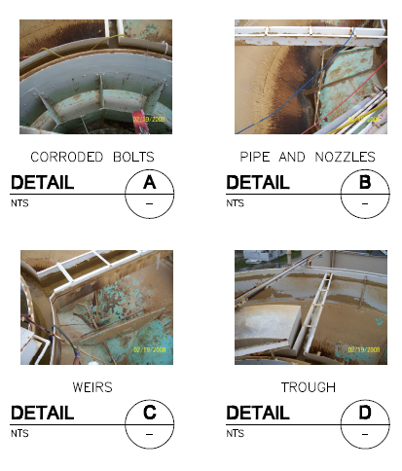
Figure - 1 (a-d) bid information of coondition of accelators

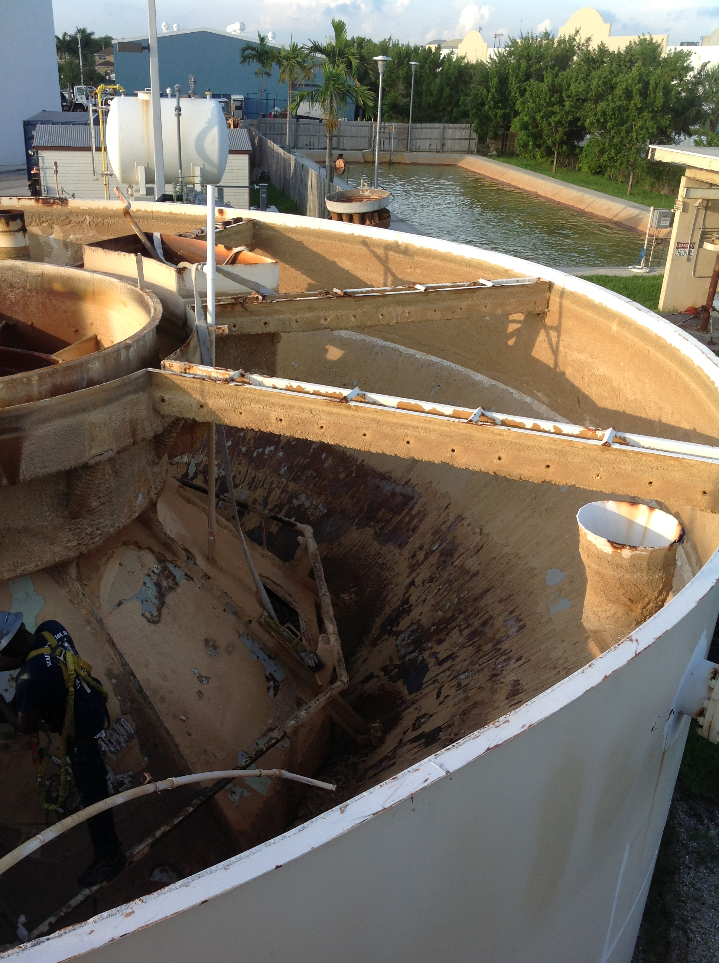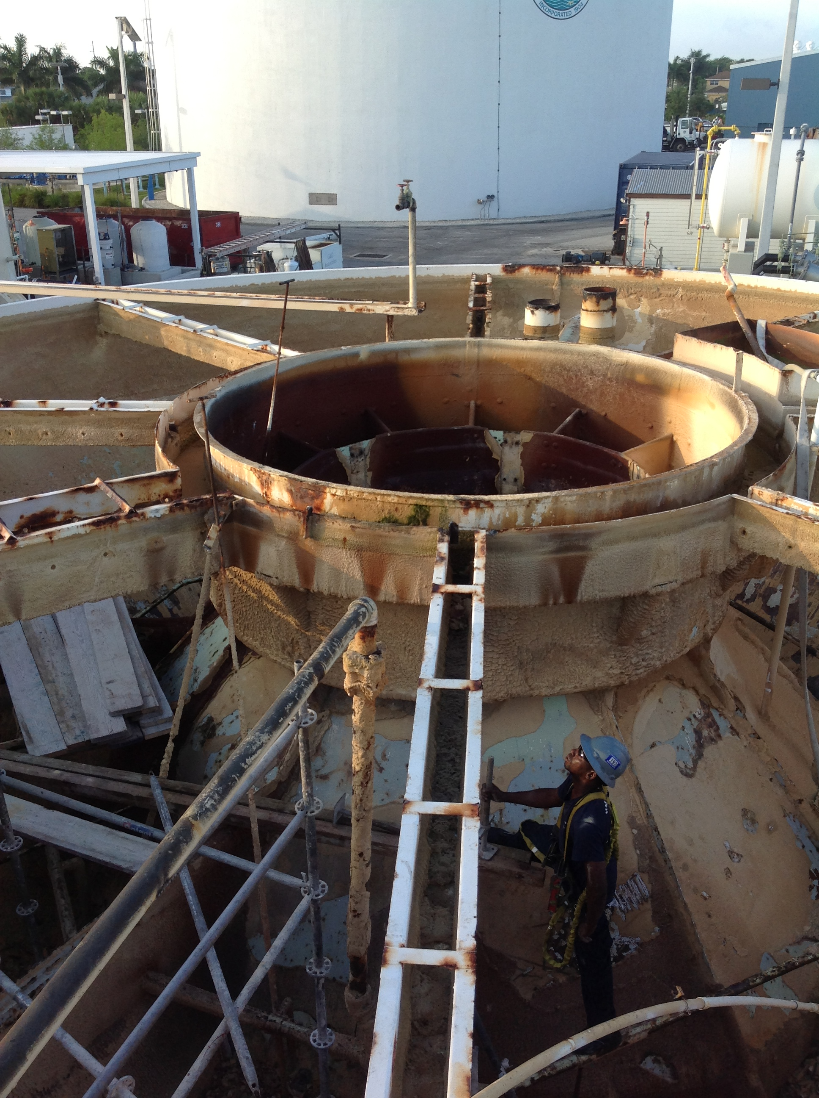

Figures - 2 and 3 – heavy lime sludge toward bottom of west accelator

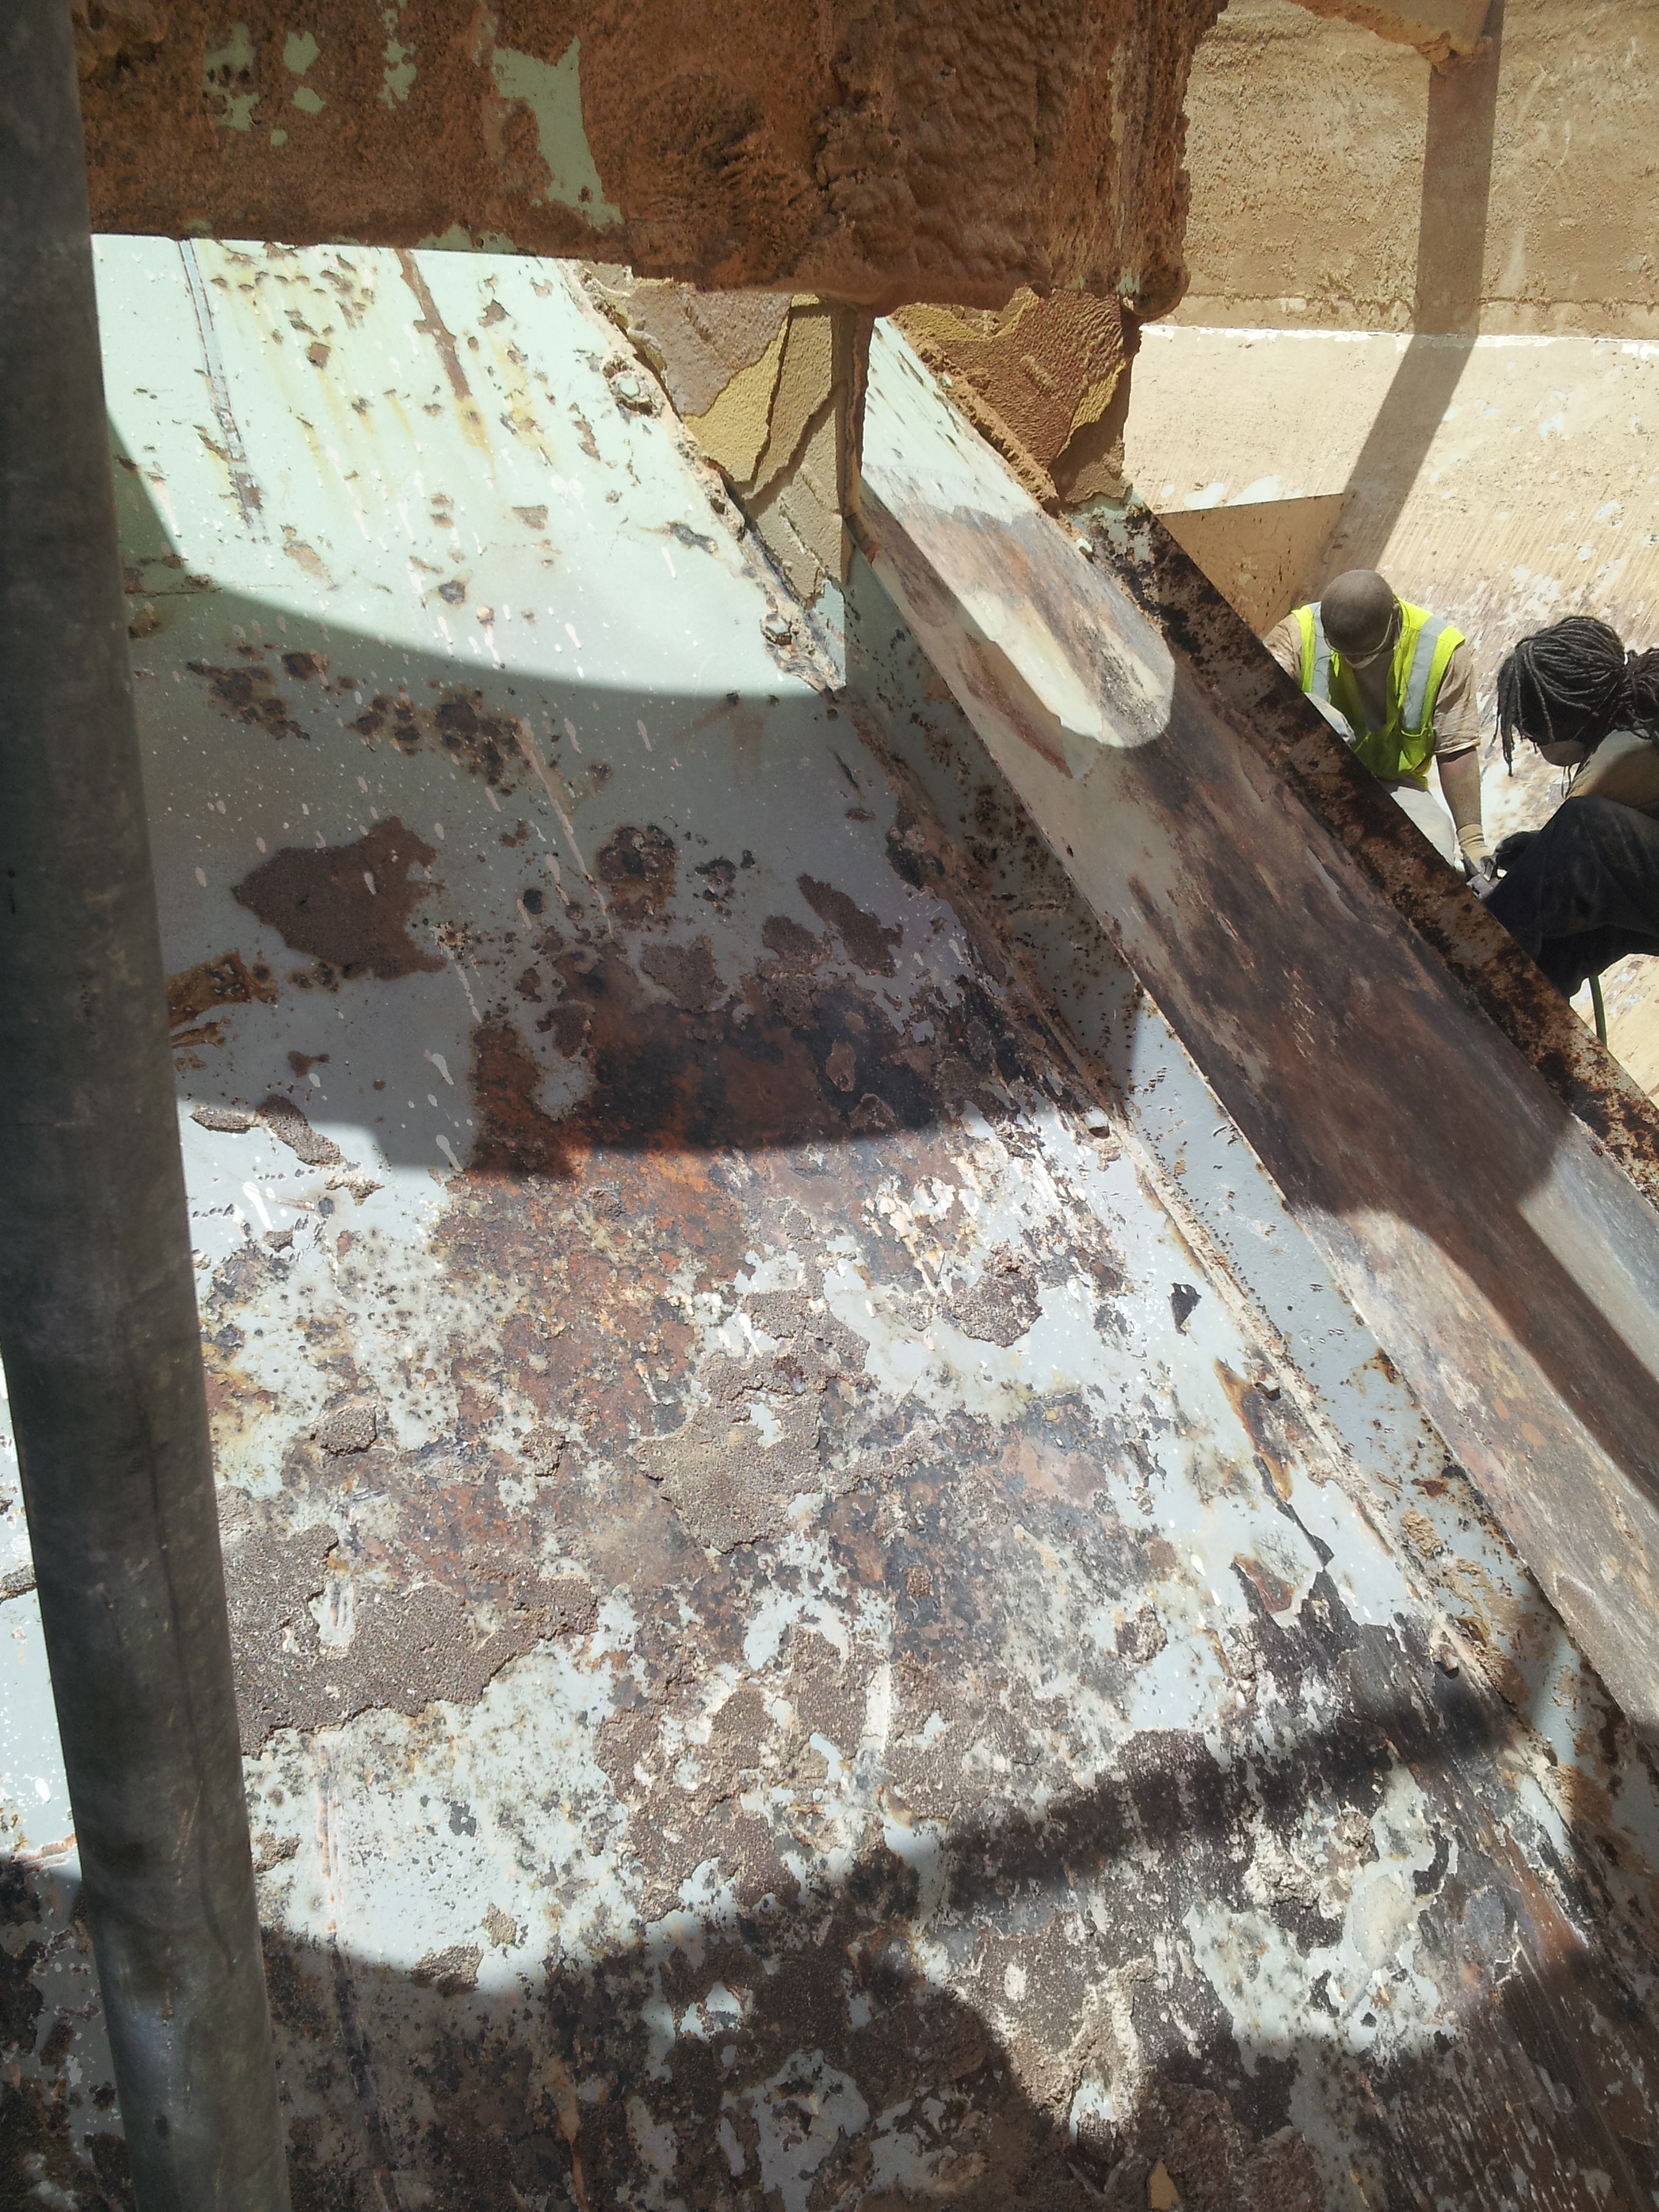

Figure - 4 - Glass-like lime sludge on west accelator

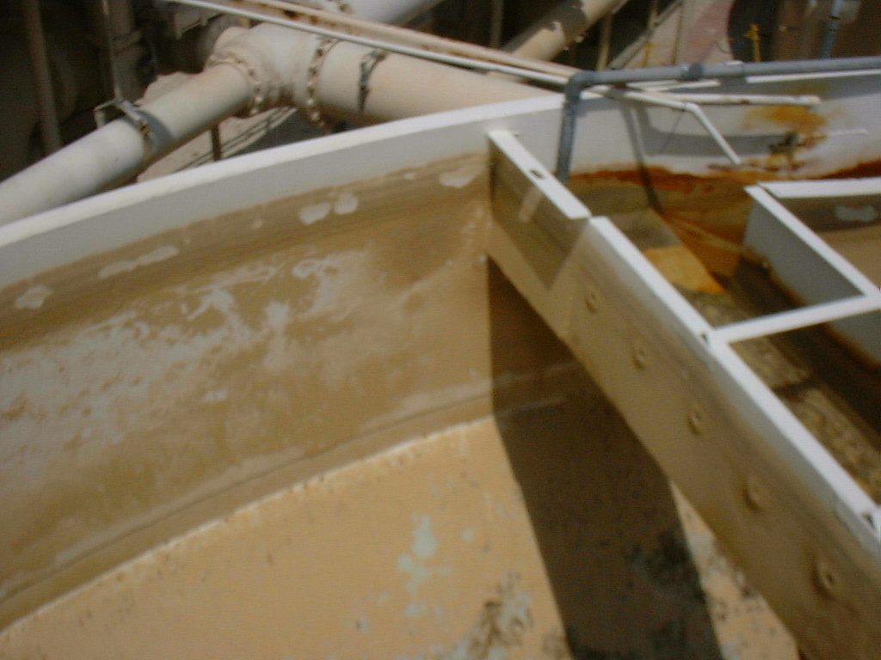

Figure 5 – East Accelator

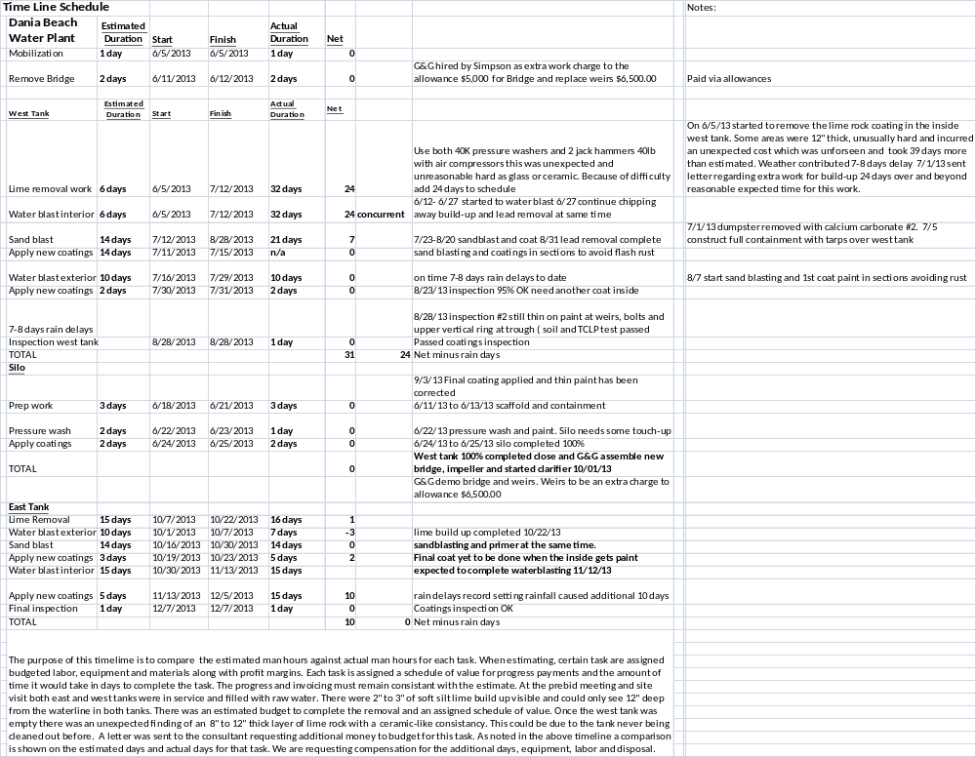

There were several other minor issues during construction. The contract included a $25,000 allowance for metal repairs. A decision was made to replace the lauders at less cost than repairs (which had been made at least twice before). The other changes are as follows:

Item In Bid Change
Metal Repair Allowance | $25,000.00 | ($25,000.00)
Bridge Removal |  | $5,000.00
Weirs Removal West Tank |  | $6,500.00
Weirs Removal East Tank |  | $6,000.00
Delay |  | $84,000.00

Overall this causes a change to the contract as follows:

Original Contract | 385,000.00
Net Change (above) | 76,500.00
Final Contract | 461,500.00

Recommendation
It is recommended that the City Commission approve Change Order No. 1 to the Contract for lead abatement with Simpson Environmental Services, Inc., adding an amount of $76,500.00 to their original approved service agreement, increasing the total Contract award to $461,500.00 and direct the City Manager to execute same. Funds for this Change Order No. 1 are available and will be taken from the Unappropriated Water Fund Net Resources Account and the Water Fund Contingency Account.

